Name: Apurba Koirala
22BCE3799
Deep Learning Lab Assessment 2
Guided by: Dr. C Sharmila

- Implement a Convolutional Neural Network (CNN) for face recognition using a labeled face image dataset such as LFW, CelebA, or a custom dataset. The model should classify images to accurately identify different individuals.

from sklearn.datasets import fetch_lfw_people
from sklearn.model_selection import train_test_split
from sklearn.preprocessing import LabelEncoder
import numpy as np

lfw_people = fetch_lfw_people(min_faces_per_person=50, resize=1.0, color = False)

lfw = fetch_lfw_people(min_faces_per_person=50, resize=1.0, color=False)
images, labels = lfw_people.images, lfw_people.target
target_names = lfw_people.target_names

X = images.astype("float32")
if X.max() > 2.0:
X /= 255.0
X = np.expand_dims(X, -1)
y = labels

X_train, X_test, y_train, y_test = train_test_split(X, y, test_size=0.2, random_state=42)

print(f"\nDataset split:")
print(f"X_train shape: {X_train.shape}")
print(f"y_train shape: {y_train.shape}")
print(f"X_test shape: {X_test.shape}")
print(f"y_test shape: {y_test.shape}")

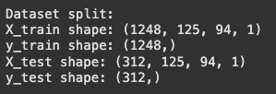
from sklearn.preprocessing import LabelBinarizer
lb = LabelBinarizer()
y_train_ohe = lb.fit_transform(y_train)
y_test_ohe = lb.transform(y_test)

from tensorflow.keras.models import Sequential
from tensorflow.keras.layers import Conv2D, MaxPooling2D, Flatten, Dense

# Create a Sequential model
model = Sequential()

# Add the first Convolutional layer
model.add(Conv2D(filters=32, kernel_size=(3, 3), activation='relu', input_shape=(h, w, 1)))

# Add the first MaxPooling layer
model.add(MaxPooling2D(pool_size=(2, 2)))

# Add the second Convolutional layer
model.add(Conv2D(filters=64, kernel_size=(3, 3), activation='relu'))

# Add the second MaxPooling layer
model.add(MaxPooling2D(pool_size=(2, 2)))

# Add a Flatten layer
model.add(Flatten())

# Add a Dense layer
model.add(Dense(units=128, activation='relu'))

# Add the output Dense layer
model.add(Dense(units=n_classes, activation='softmax'))

# Print the model summary
model.summary()

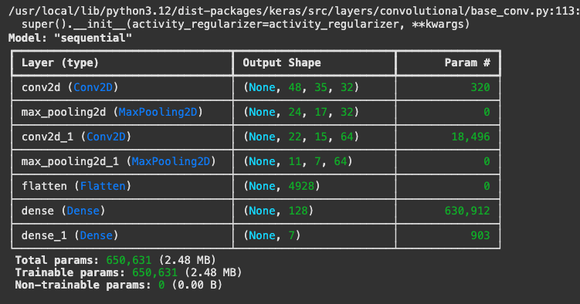
model.compile(optimizer='adam',
loss='categorical_crossentropy',
metrics=['accuracy'])

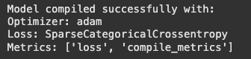
# Define training parameters
epochs = 10
batch_size = 32

# Train the model
history = model.fit(X_train, y_train_ohe, epochs=epochs, batch_size=batch_size, validation_split=0.1, verbose=1)

# Display the history object
print("Training history:")
print(history.history.keys())
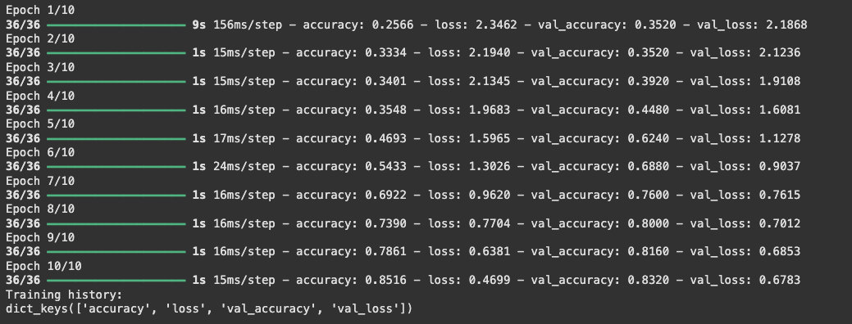

loss, acc = model.evaluate(X_test, y_test_ohe, verbose=0)
print(f"Test accuracy: {acc:.4f}")

import matplotlib.pyplot as plt
y_pred = np.argmax(model.predict(X_test), axis=1)
def show_predictions(Xs, ys_true, ys_pred, names, n=10):
plt.figure(figsize=(15,6))
for i in range(n):
plt.subplot(2, 5, i+1)
plt.imshow(Xs[i].squeeze(), cmap="gray")
plt.title(f"T:{names[ys_true[i]]}\nP:{names[ys_pred[i]]}", fontsize=9)
plt.axis("off")
plt.tight_layout()

show_predictions(X_test, y_test, y_pred, target_names, n=4)
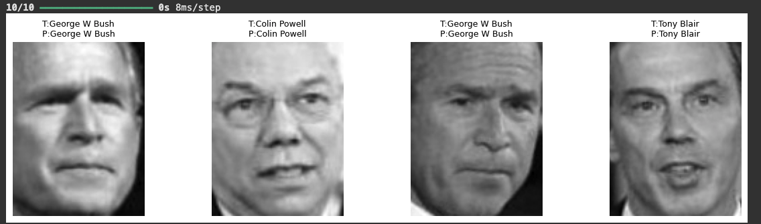

2. Download the Churn Modeling dataset.
a. Apply deep learning techniques to train and test the data using a 70:30 split.
- Design the model with hyperparameter tuning for hidden layers, output layer,dropout rates, and activation functions.
- Plot the comparative graph of the performance ( at least three best performanceofhyper parameter tuning)
b. Read an .jpg or .png image and get the following output
- Print original image
- Print the feature map after convolution layer (tensor and image)
- Print the feature map after the pooling layer
- Provide an analysis of the feature extraction process based on the results.

import pandas as pd
import numpy as np
from sklearn.model_selection import train_test_split
from sklearn.preprocessing import StandardScaler, OneHotEncoder
from sklearn.compose import ColumnTransformer
from sklearn.pipeline import Pipeline
import tensorflow as tf
from tensorflow.keras import layers, models
import matplotlib.pyplot as plt
import cv2

df = pd.read_csv("Churn_Modelling.csv")

from sklearn.model_selection import train_test_split
from sklearn.preprocessing import LabelEncoder, StandardScaler

# Features and target
X = df.drop(columns=["RowNumber", "CustomerId", "Surname", "Exited"])
y = df["Exited"]

# Encode categorical features
le_geo = LabelEncoder()
X["Geography"] = le_geo.fit_transform(X["Geography"])

le_gen = LabelEncoder()
X["Gender"] = le_gen.fit_transform(X["Gender"])

# Train test split
X_train, X_test, y_train, y_test = train_test_split(X, y, test_size=0.3, random_state=42, stratify=y)

# Scale features
scaler = StandardScaler()
X_train = scaler.fit_transform(X_train)
X_test = scaler.transform(X_test)

print("Train shape:", X_train.shape, "Test shape:", X_test.shape)
def build_model(units1=64, units2=32, dropout=0.3, activation='relu'):
model = models.Sequential([
layers.Dense(units1, activation=activation, input_shape=(X_train.shape[1],)),
layers.Dropout(dropout),
layers.Dense(units2, activation=activation),
layers.Dropout(dropout),
layers.Dense(1, activation="sigmoid")
])
model.compile(optimizer="adam", loss="binary_crossentropy", metrics=["accuracy"])
return model

# Different hyperparameter setups
configs = [
{"units1":64, "units2":32, "dropout":0.3, "activation":"relu"},
{"units1":128,"units2":64, "dropout":0.4, "activation":"tanh"},
{"units1":256,"units2":128,"dropout":0.5, "activation":"relu"}
]

histories = []
results = []

for i, cfg in enumerate(configs):
print(f"\nTraining Model {i+1} with config: {cfg}")
model = build_model(**cfg)
history = model.fit(X_train, y_train, validation_data=(X_test,y_test), epochs=20, batch_size=32, verbose=0)
loss, acc = model.evaluate(X_test, y_test, verbose=0)
results.append({"config": cfg, "accuracy": acc})
histories.append(history)

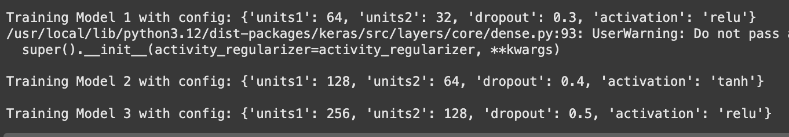
plt.figure(figsize=(12,6))
for i, history in enumerate(histories):
plt.plot(history.history['val_accuracy'], label=f'Model {i+1}')
plt.title("Validation Accuracy Comparison")
plt.xlabel("Epochs")
plt.ylabel("Accuracy")
plt.legend()
plt.show()

# Plot loss
plt.figure(figsize=(12,6))
for i, history in enumerate(histories):
plt.plot(history.history['val_loss'], label=f'Model {i+1}')
plt.title("Validation Loss Comparison")
plt.xlabel("Epochs")
plt.ylabel("Loss")
plt.legend()
plt.show()

print("\nFinal Test Accuracies:")
for r in results:
print(r)

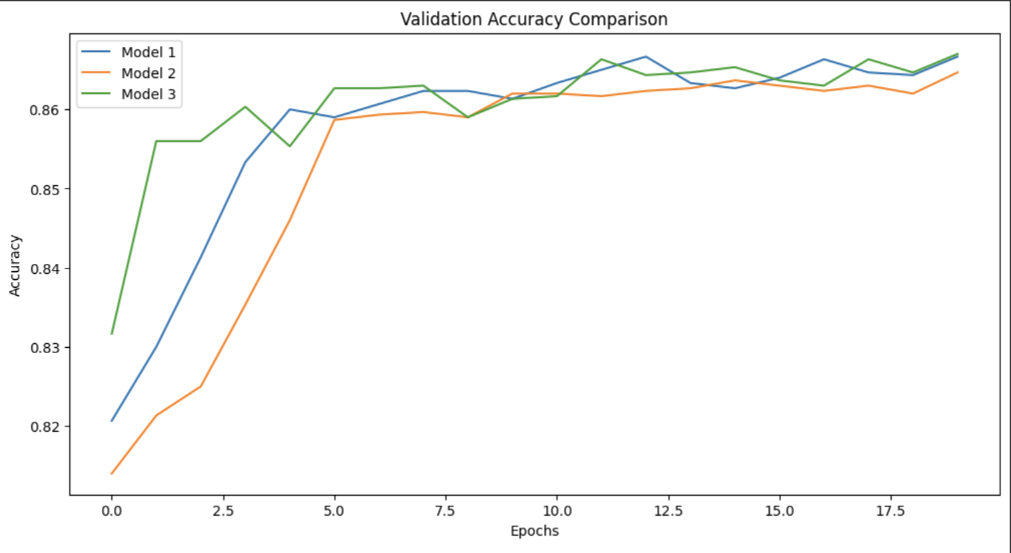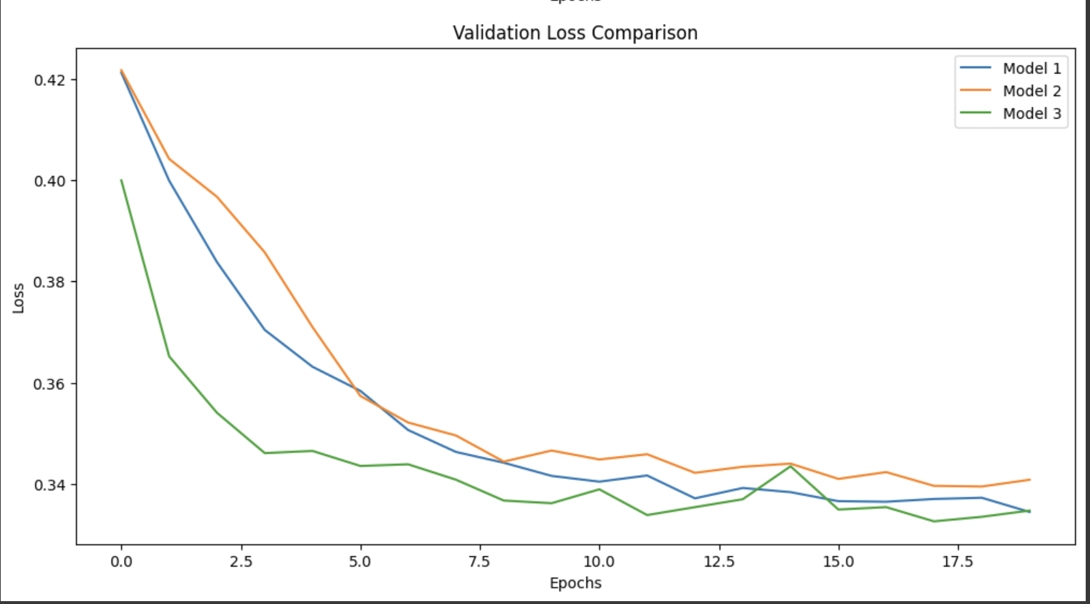
file_path = "jorse.jpeg"
img = cv2.imread(file_path)
img = cv2.cvtColor(img, cv2.COLOR_BGR2RGB)
img = cv2.resize(img, (128,128))
img_tensor = np.expand_dims(img / 255.0, axis=0)

inputs = layers.Input(shape=(128,128,3))
x = layers.Conv2D(16, (3,3), activation='relu')(inputs)
x_pool = layers.MaxPooling2D((2,2))(x)

model = models.Model(inputs=inputs, outputs=x_pool)

conv_model = models.Model(inputs=inputs, outputs=x)
pool_model = models.Model(inputs=inputs, outputs=x_pool)

conv_features = conv_model.predict(img_tensor)
pool_features = pool_model.predict(img_tensor)

print("Conv feature map shape:", conv_features.shape)
print("Pooling feature map shape:", pool_features.shape)

# Original image
plt.subplot(1,3,1)
plt.imshow(img)
plt.title("Original Image")
plt.axis("off")

# Conv feature map (first filter)
plt.subplot(1,3,2)
plt.imshow(conv_features[0,:,:,0], cmap="viridis")
plt.title("Conv Feature Map")
plt.axis("off")

# Pooling feature map (first filter)
plt.subplot(1,3,3)
plt.imshow(pool_features[0,:,:,0], cmap="viridis")
plt.title("Pooling Feature Map")
plt.axis("off")

plt.show()

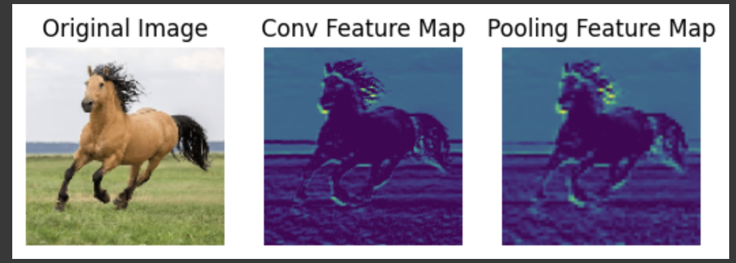

- Implement a Convolutional Neural Network (CNN) using Keras to classify images from the CIFAR-10 dataset. Load the dataset, normalize the images, and apply one-hot encoding to the labels. Build a CNN with at least three convolutional layers, pooling layers, a flatten layer, and a dense output layer with softmax activation. Compile the model using the Adam optimizer and categorical crossentropy loss, then train it for 20 epochs. Plot accuracy and loss curves, evaluate the model on the test set, and print the final test accuracy.

import tensorflow as tf
from tensorflow.keras.datasets import cifar10
from tensorflow.keras.utils import to_categorical
import matplotlib.pyplot as plt

# Load the CIFAR-10 dataset
(x_train, y_train), (x_test, y_test) = cifar10.load_data()

# Normalize pixel values to be between 0 and 1
x_train, x_test = x_train / 255.0, x_test / 255.0

# One-hot encode the labels
y_train = to_categorical(y_train, num_classes=10)
y_test = to_categorical(y_test, num_classes=10)

model = models.Sequential([
layers.Conv2D(32, (3,3), activation="relu", padding="same", input_shape=x_train.shape[1:]),
layers.MaxPooling2D((2,2)),

layers.Conv2D(64, (3,3), activation="relu", padding="same"),
layers.MaxPooling2D((2,2)),

layers.Conv2D(128, (3,3), activation="relu", padding="same"),
layers.MaxPooling2D((2,2)),

layers.Flatten(),
layers.Dense(128, activation="relu"),
layers.Dropout(0.4),
layers.Dense(10, activation="softmax")
])

# Compile the model
model.compile(optimizer='adam',
loss='categorical_crossentropy',
metrics=['accuracy'])

# Train the model
h = model.fit(x_train, y_train, epochs=20, validation_data=(x_test, y_test))

# Plot accuracy and loss curves
plt.figure(figsize=(12, 4))
plt.subplot(1, 2, 1)
plt.plot(h.history['accuracy'], label='accuracy')
plt.plot(h.history['val_accuracy'], label='val_accuracy')
plt.xlabel('Epoch')
plt.ylabel('Accuracy')
plt.legend()

plt.subplot(1, 2, 2)
plt.plot(h.history['loss'], label='loss')
plt.plot(h.history['val_loss'], label='val_loss')
plt.xlabel('Epoch')
plt.ylabel('Loss')
plt.legend()
plt.show()

# Evaluate the model
loss, acc = model.evaluate(x_test, y_test, verbose=2)
print(f"Test accuracy: {acc}")
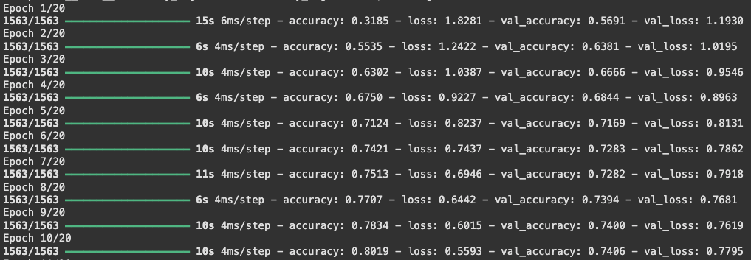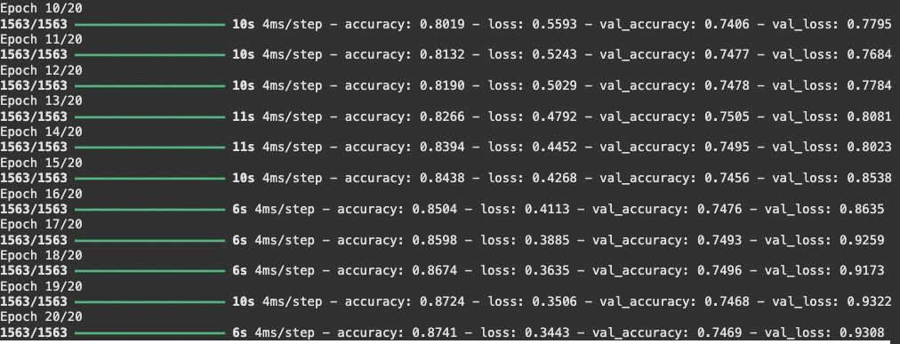

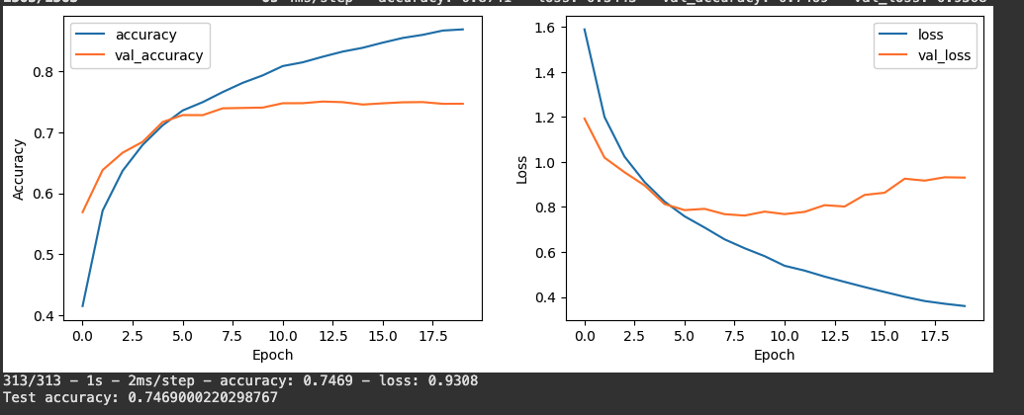
The model has overfitted, early stopping to be applied for better results.

4. Download any medical imaging dataset and compare the performance of AlexNet, ResNet,
and InceptionNet architectures on the same dataset. Record the training time, training accuracy,
validation accuracy, and test accuracy for each model. Plot and compare the graphs of Training
vs. Validation Accuracy and Training vs. Validation Loss for all three models. Analyze and
report which architecture achieved the best performance based on the results.

import time
import numpy as np
import tensorflow as tf
from tensorflow.keras import Input, Model, Sequential
from tensorflow.keras.layers import (
Conv2D, MaxPooling2D, Flatten, Dense, Dropout, Activation,
BatchNormalization, AveragePooling2D, concatenate, GlobalAveragePooling2D
)
from tensorflow.keras.utils import to_categorical
from sklearn.model_selection import train_test_split

fashion_mnist = tf.keras.datasets.fashion_mnist
(train_images, train_labels), (test_images, test_labels) = fashion_mnist.load_data()
all_images = np.concatenate([train_images, test_images], axis=0).astype('float32') / 255.0
all_labels = np.concatenate([train_labels, test_labels], axis=0)
all_images = np.expand_dims(all_images, axis=-1) # shape (N,28,28,1)

# Stratified splits: 70/15/15
X_train, X_temp, y_train, y_temp = train_test_split(
all_images, all_labels, test_size=0.30, random_state=42, stratify=all_labels
)
X_val, X_test, y_val, y_test = train_test_split(
X_temp, y_temp, test_size=0.50, random_state=42, stratify=y_temp
)

print("Shapes:", X_train.shape, X_val.shape, X_test.shape)

input_shape = (28, 28, 1)
num_classes = 10

Three functions for the three transfer learning models
def build_simplified_alexnet_adjusted(input_shape, num_classes):
model = Sequential([
Conv2D(32, (3, 3), strides=(1, 1), activation='relu', input_shape=input_shape, padding='same'),
MaxPooling2D((2, 2)),
Conv2D(64, (3, 3), activation='relu', padding='same'),
MaxPooling2D((2, 2)),
Conv2D(128, (3, 3), activation='relu', padding='same'),
Conv2D(128, (3, 3), activation='relu', padding='same'),
Conv2D(64, (3, 3), activation='relu', padding='same'),
MaxPooling2D((2, 2)),
Flatten(),
Dense(512, activation='relu'),
Dropout(0.5),
Dense(512, activation='relu'),
Dropout(0.5),
Dense(num_classes, activation='softmax')
])
return model

def build_simplified_resnet(input_shape, num_classes):
from tensorflow.keras.layers import Reshape # local import if needed
def identity_block(x, filters, kernel_size):
x_skip = x
x = Conv2D(filters, kernel_size, padding='same')(x)
x = BatchNormalization(axis=3)(x)
x = Activation('relu')(x)
x = Conv2D(filters, kernel_size, padding='same')(x)
x = BatchNormalization(axis=3)(x)
x = concatenate([x, x_skip])
x = Activation('relu')(x)
return x

def convolutional_block(x, filters, kernel_size, strides=(2, 2)):
x_skip = x
x = Conv2D(filters, kernel_size, strides=strides, padding='same')(x)
x = BatchNormalization(axis=3)(x)
x = Activation('relu')(x)
x = Conv2D(filters, kernel_size, padding='same')(x)
x = BatchNormalization(axis=3)(x)
x_skip = Conv2D(filters, (1, 1), strides=strides, padding='same')(x_skip)
x_skip = BatchNormalization(axis=3)(x_skip)
x = concatenate([x, x_skip])
x = Activation('relu')(x)
return x

input_tensor = Input(shape=input_shape)
x = Conv2D(32, (3, 3), strides=(1, 1), padding='same')(input_tensor)
x = BatchNormalization(axis=3)(x)
x = Activation('relu')(x)
x = MaxPooling2D((3, 3), strides=(2, 2), padding='same')(x)

x = convolutional_block(x, 32, (3, 3), strides=(1,1)) # avoid too aggressive downsample
x = identity_block(x, 32, (3, 3))

x = convolutional_block(x, 64, (3, 3), strides=(1,1))
x = identity_block(x, 64, (3, 3))

# FIX: use adaptive global pooling instead of fixed 7x7
x = GlobalAveragePooling2D(name='global_avg_pool')(x) # -> (batch, channels)
x = Dense(num_classes, activation='softmax', name='fc10')(x)

model = Model(inputs=input_tensor, outputs=x, name='resnet_simplified')
return model

def build_simplified_inception(input_shape, num_classes):
def inception_module(x, filters_1x1, filters_3x3_reduce, filters_3x3, filters_5x5_reduce, filters_5x5, filters_pool_proj):
conv_1x1 = Conv2D(filters_1x1, (1, 1), padding='same', activation='relu')(x)

conv_3x3 = Conv2D(filters_3x3_reduce, (1, 1), padding='same', activation='relu')(x)
conv_3x3 = Conv2D(filters_3x3, (3, 3), padding='same', activation='relu')(conv_3x3)

conv_5x5 = Conv2D(filters_5x5_reduce, (1, 1), padding='same', activation='relu')(x)
conv_5x5 = Conv2D(filters_5x5, (5, 5), padding='same', activation='relu')(conv_5x5)

pool_proj = MaxPooling2D((3, 3), strides=(1, 1), padding='same')(x)
pool_proj = Conv2D(filters_pool_proj, (1, 1), padding='same', activation='relu')(pool_proj)

output = concatenate([conv_1x1, conv_3x3, conv_5x5, pool_proj], axis=3)
return output

input_tensor = Input(shape=input_shape)

x = Conv2D(32, (3, 3), strides=(1, 1), padding='same', activation='relu')(input_tensor)
x = MaxPooling2D((2, 2), strides=(2, 2), padding='same')(x)

x = Conv2D(64, (1, 1), padding='same', activation='relu')(x)
x = Conv2D(96, (3, 3), padding='same', activation='relu')(x)
x = MaxPooling2D((2, 2), strides=(2, 2), padding='same')(x)

x = inception_module(x, 32, 48, 64, 8, 16, 16)
x = inception_module(x, 64, 64, 96, 16, 48, 32)
x = MaxPooling2D((2, 2), strides=(2, 2), padding='same')(x)

x = GlobalAveragePooling2D()(x)
x = Dense(num_classes, activation='softmax')(x)

model = Model(inputs=input_tensor, outputs=x, name='inception_simplified')
return model

alexnet_model = build_simplified_alexnet_adjusted(input_shape, num_classes)
resnet_model = build_simplified_resnet(input_shape, num_classes)
inception_model = build_simplified_inception(input_shape, num_classes)

for m in (alexnet_model, resnet_model, inception_model):
m.compile(optimizer='adam', loss='sparse_categorical_crossentropy', metrics=['accuracy'])

print("\nAlexNet summary:")
alexnet_model.summary()
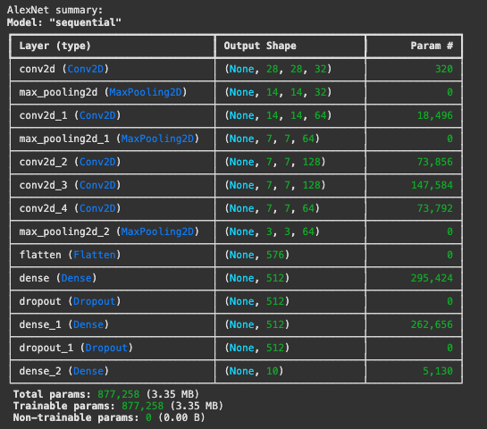
print("\nResNet summary:")
resnet_model.summary()

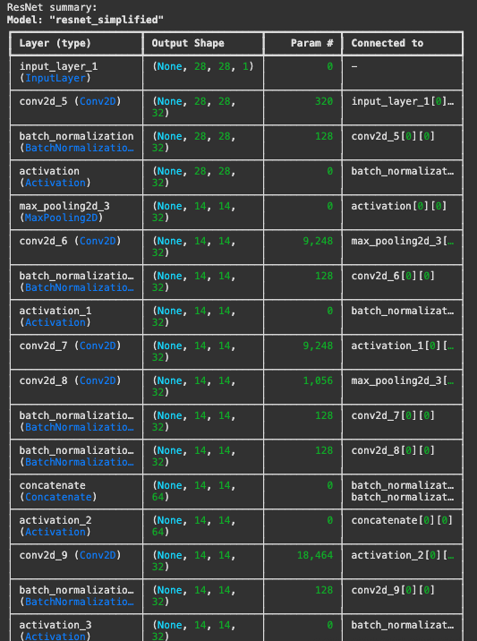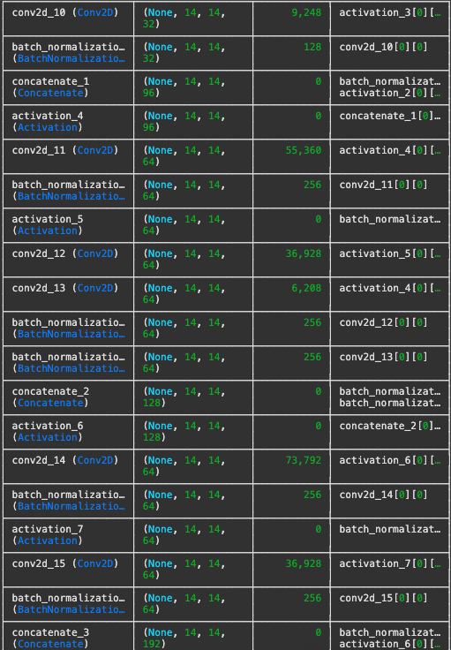
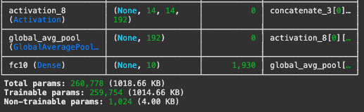
print("\nInception summary:")
inception_model.summary()

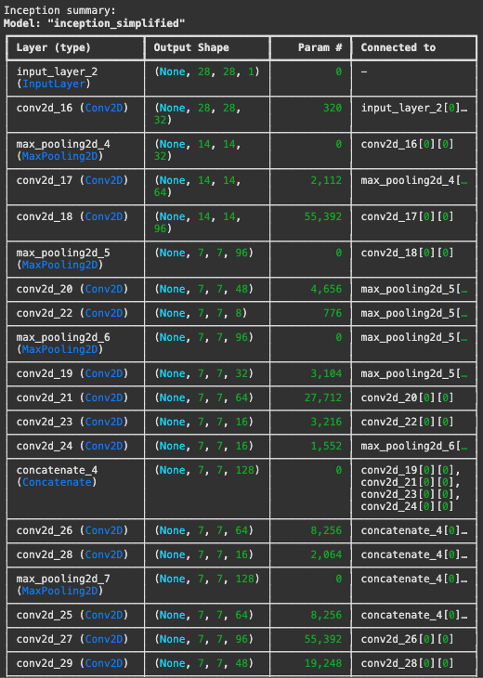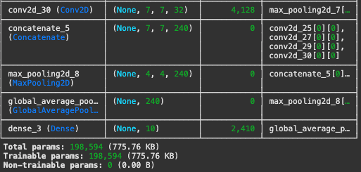
EPOCHS = 15
BATCH_SIZE = 128

histories = {}
times = {}

print("\nTraining AlexNet...")
t0 = time.time()
histories['alexnet'] = alexnet_model.fit(X_train, y_train,
epochs=EPOCHS,
batch_size=BATCH_SIZE,
validation_data=(X_val, y_val),
verbose=1)

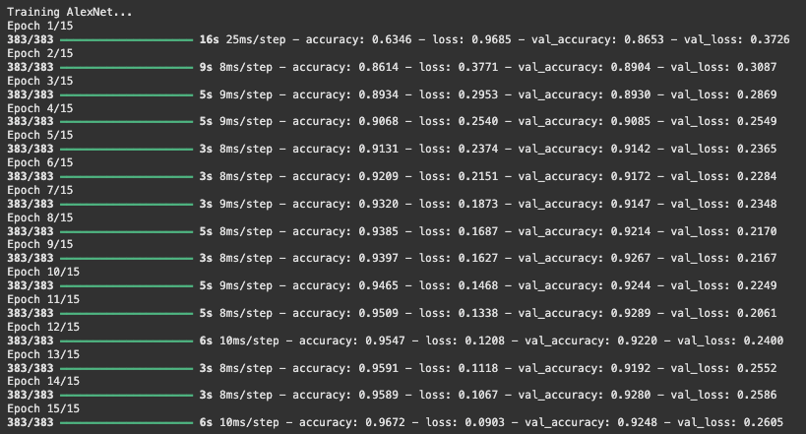
times['alexnet'] = time.time() - t0
print("AlexNet time:", times['alexnet'])

print("\nTraining ResNet...")
t0 = time.time()
histories['resnet'] = resnet_model.fit(X_train, y_train,
epochs=EPOCHS,
batch_size=BATCH_SIZE,
validation_data=(X_val, y_val),
verbose=1)
times['resnet'] = time.time() - t0
print("ResNet time:", times['resnet'])
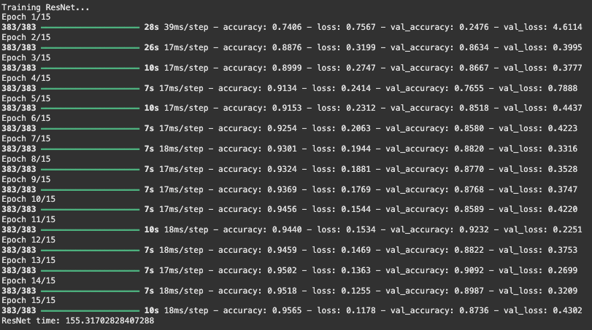
print("\nTraining Inception...")
t0 = time.time()
histories['inception'] = inception_model.fit(X_train, y_train,
epochs=EPOCHS,
batch_size=BATCH_SIZE,
validation_data=(X_val, y_val),
verbose=1)
times['inception'] = time.time() - t0
print("Inception time:", times['inception'])
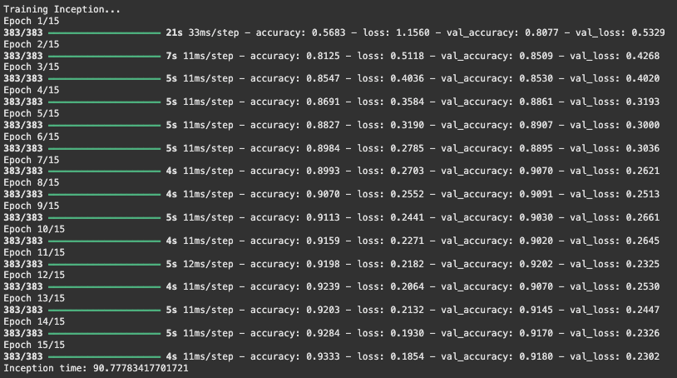print("\nRecorded training times keys:", list(times.keys()))

print("\nEvaluating models on test set:")
for name, model in [('alexnet', alexnet_model),
('resnet', resnet_model),
('inception', inception_model)]:
loss, acc = model.evaluate(X_test, y_test, verbose=0)
tt = times.get(name, None) # safe lookup
if tt is None:
tt_str = "N/A" # training time not recorded
else:
tt_str = f"{tt:.1f}s"
print(f"{name:10s} loss={loss:.4f} acc={acc:.4f} train_time={tt_str}")

